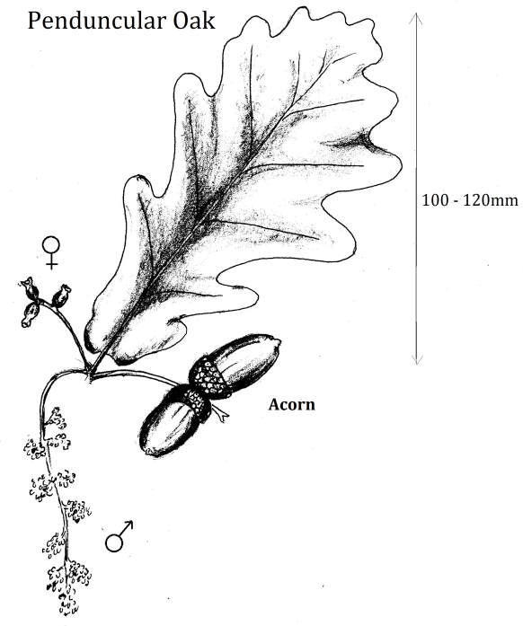

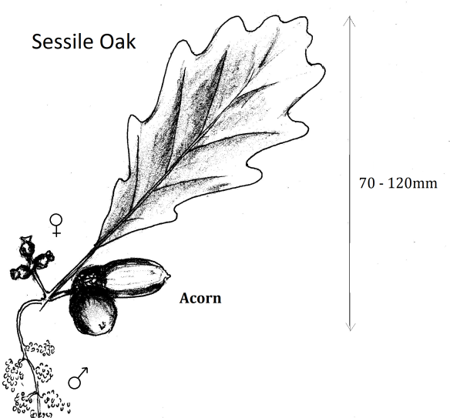

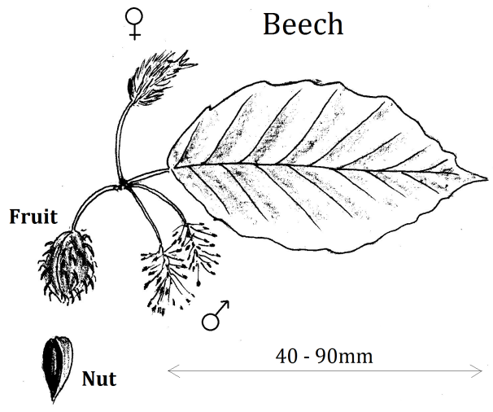

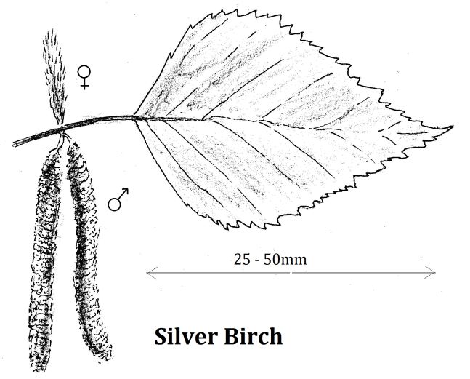

Penduncular (English) Oak
Flowers: May – June. Male and female catkins found on same tree. A native tree.
The leaf is described as “narrow”, and has two "ears" at the base of the leaf. Short leaf stalk, 5mm at most.
The acorns form on a stalk several centimetres long.
Hybrids are commonly particularly with Hungarian Oak, amongst others. Look for flattened acorns.

Sessile Oak
Flowers: May. Male and female catkins found on same tree. A native tree
The leaf is described as “broad”. Long leaf stalk. Stalkless acorns.
Trunk long and smooth.

Beech
Flowers: April – May. Male and female flowers are separate but on the same tree.
Leaves are decay-resistant which discourages ground plant growth. This native tree has a dense canopy.
Smooth, grey bark.
Two nuts develop in a four lobed “involucre” (bracts that surround the nut).
Silver Birch
Flowers: April – May. Male and female catkins found on same tree. Tiny nut with scale wings.
Silvery-white bark with dark rectangular plates at the base of the trunk. A pioneering native species.
It is similar to the Downy Birch which they hybridise with.
Silver Birch: Double toothed leaf edge
Downy Birch: Single teeth on leaf edge. Shoots are hairy.
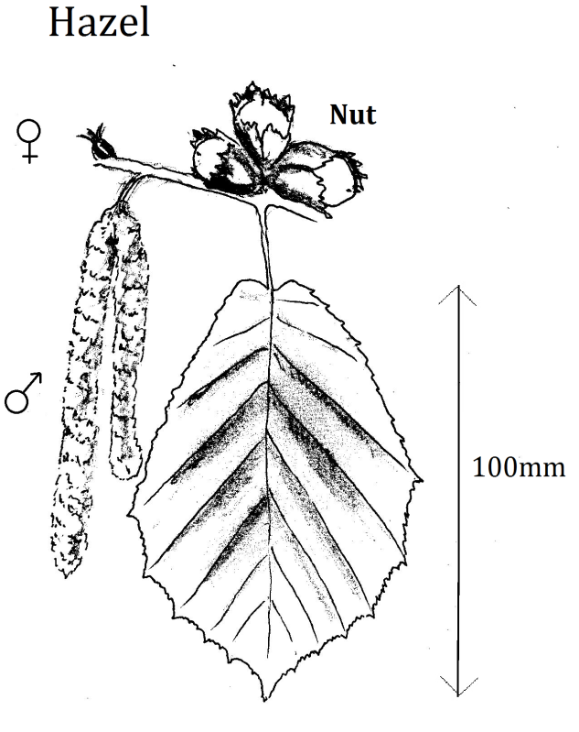

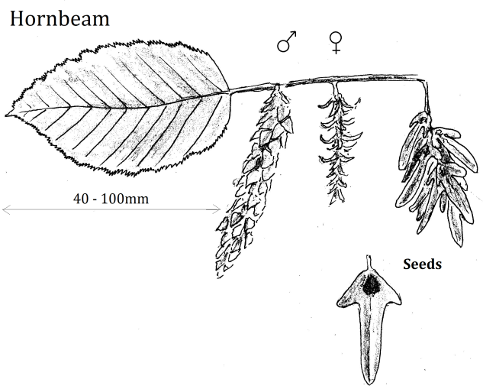

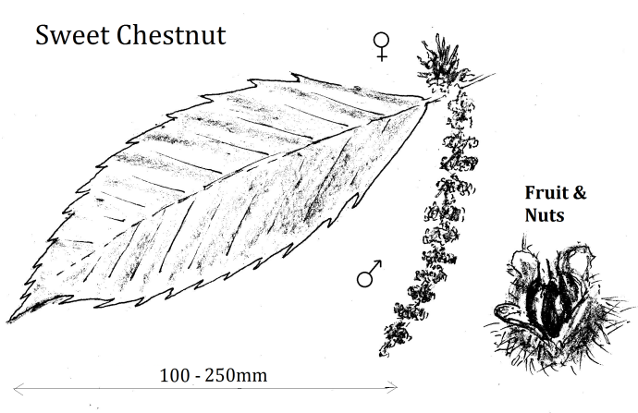
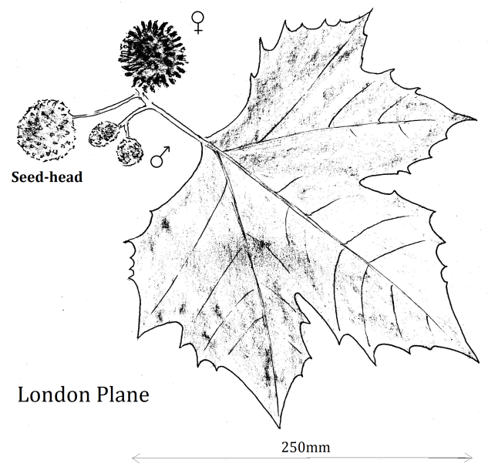

Hazel
Flowers: January- April. Male is a long catkin. Female is small red and spiky and found on the same tree.
Leaves are wrinkly and bristly.
A small, bushy tree.
Hard shelled nuts enveloped within a ragged, leafy, involucres.
This is a native plant.

Hornbeam
Flowers: April – May. Male and female catkins found on same tree. Wind pollinated.
Each pair of nuts is attached by a leaf-like three lobed involucres which hangs in clusters. Wind dispersed seeds.

Sweet Chestnut
Flowers: June – July. Male, long yellowish catkins. Females, grouped in three.
A green spiny cupule forms the outer husk.
Bark grey, often spirally fissured.
Is it related to the Horse Chestnut?
London Plane
Hybrid or Cultivar. Flowers in June. The male flower is a green sphere and the female is a crimson sphere, on the same tree. Wind pollinated. The seed head is retained through the winter and then white haired seeds are released in the spring.
Its outer bark flakes off in patches and was therefore ideal for cities where smoke blackened the trunks of trees.
Probably a cross between two other plane trees or possibly a cultivar. Produced in Europe in the 16th century. Introduced into UK in the 17th century.

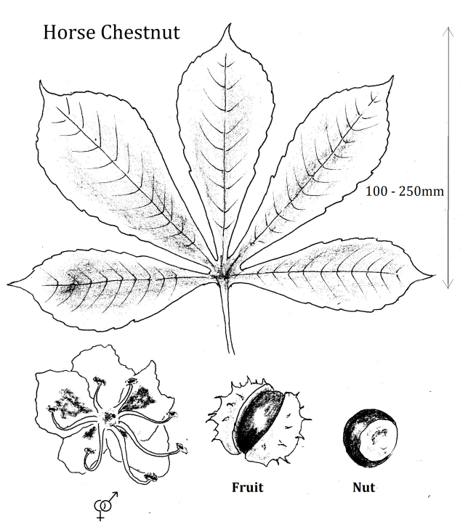
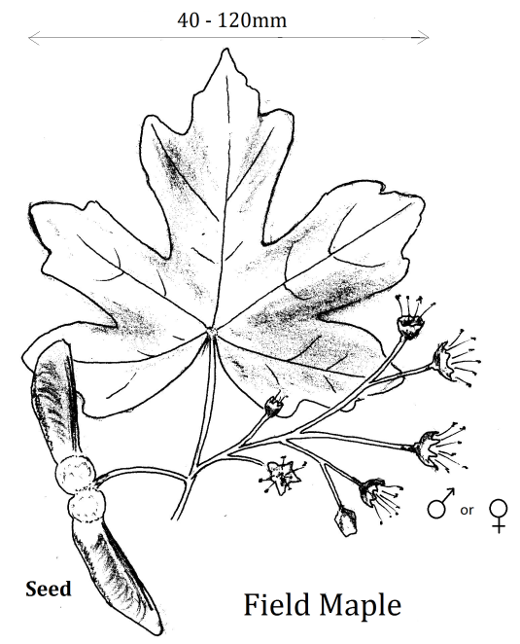

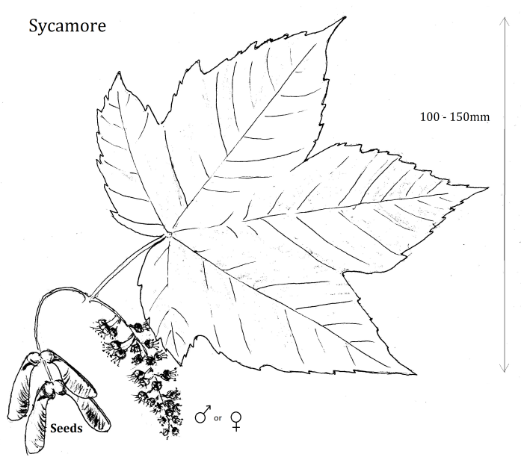
Sycamore
Flowers in April. Separate male and female flowers that look very similar are on the same tree. Both produce nectar and are therefore insect pollinated.
Bark flaky, dappled reddish brown.
Fruit in clustered pairs, each pair set at an angle of 50-60º. Winged and therefore wind dispersed.
Introduced plant, probably in the 13th or 14th century.

Field Maple
Flowers in April - June. Separate male and female flowers that look very similar are on the same tree. Both produce nectar and are therefore insect pollinated.
Fruit red-tinged in clusters of four pairs, each pair aligned. Winged and therefore wind dispersed.
Native plant.

Horse Chestnut
Flowers: May-June. Both male and female parts contained in one flower. Petals white with splashes of pink.
Introduced into Britain, from Turkey, in the late 16th century. The Red Horse Chestnut tree is a fertile hybrid.
The name possibly refers to the shape of the scar left on the twig when the leaf falls, similar shape to a horse’s hoof or that the chestnuts were crushed and given to horses with respiratory illnesses. They are poisonous to humans and other animals.

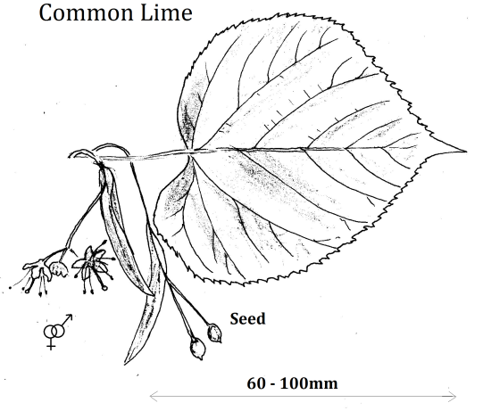

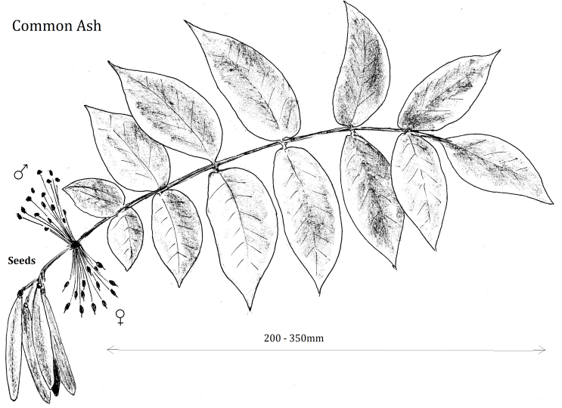
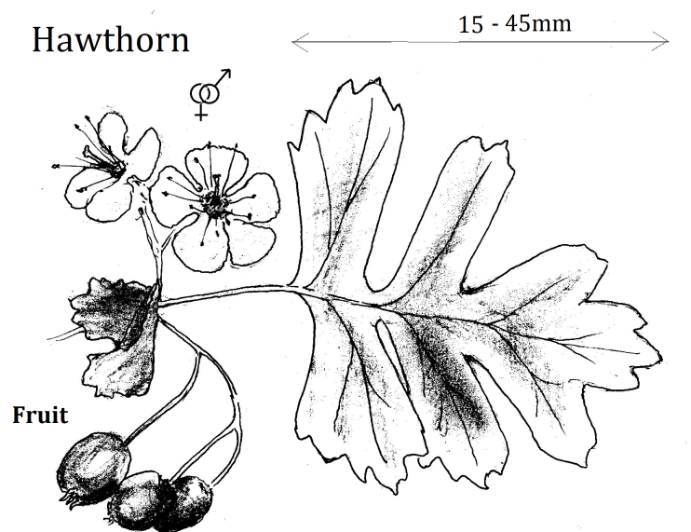
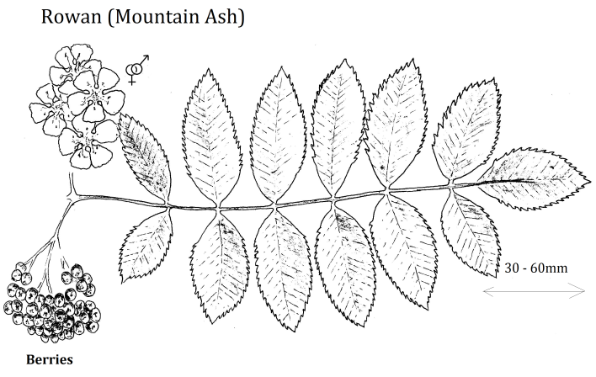

Common Lime
This is a hybrid between the Small-leaved Lime and the Broad-Leaved Lime.
Flowers in July. A fragrant flower with both male and female parts and yellow-white petals.
Seeds produced on wing like structure.
Native plant.

Common (European) Ash
Flowers April – May, the male and female flowers often found on separate trees or sometimes on different branches of the same tree.
Bark, grey and smooth.
Winged fruits, “keys”, form clusters and often stay on the tree until the following spring.
Native plant.
Ash dieback is a fungal infection that will potentially cause many individual trees to die.

Rowan (Mountain Ash)
As the name suggests it is particularly suited to mountain slopes but has been extensively planted in parks and road sides.
Flower clusters in May, each flower containing both male and female parts.
Small bright-red berries ripen in September.
Native plant. Is it related to the Common Ash?

Common and Red Hawthorn
Bush or small tree. Flowers in May – June.
The Common Hawthorn flowers are white and the Red Hawthorn flowers are red. The Red Hawthorn is variety of the Midland Hawthorn.
Berries are bright red in both species.
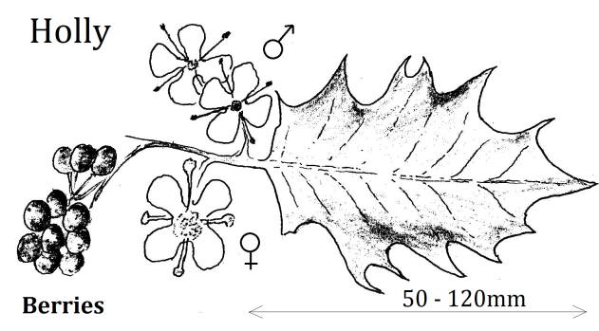
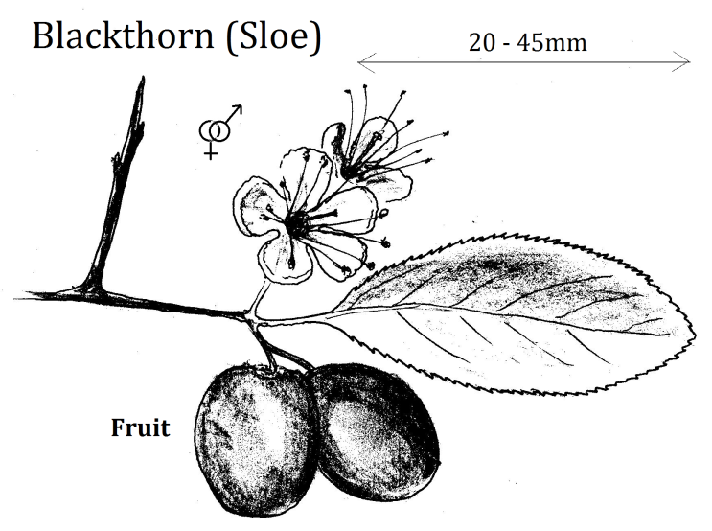

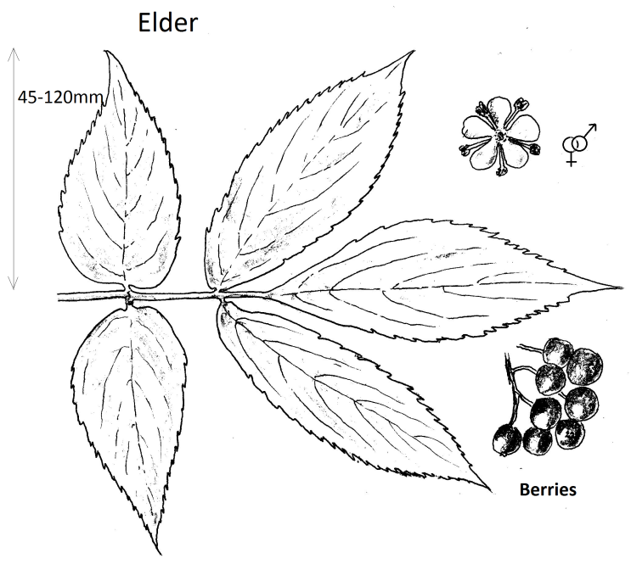

Blackthorn
Bushy tree, thorns on the ends of the of twigs.
Flowers in March – April. Both male and female found in the same flower. Large blue-black fruit with green acidic flesh.
Native species.

Holly
Flowers in May – August. Male and female flowers on separate trees. Superficially the flowers look the same but the female does not have functioning stamens and the male does not have a developed stigma. Only the male flower has a scent.
Red berries.
Evergreen native shrub or tree. An invasive species.

Elder
Bushy tree with stems growing directly from the base.
Flowers June-July. Flat flower-cluster of numerous white flowers containing both male and female parts.
Barkgrey or light brown, grooved and corkey.
Berries black when ripe.

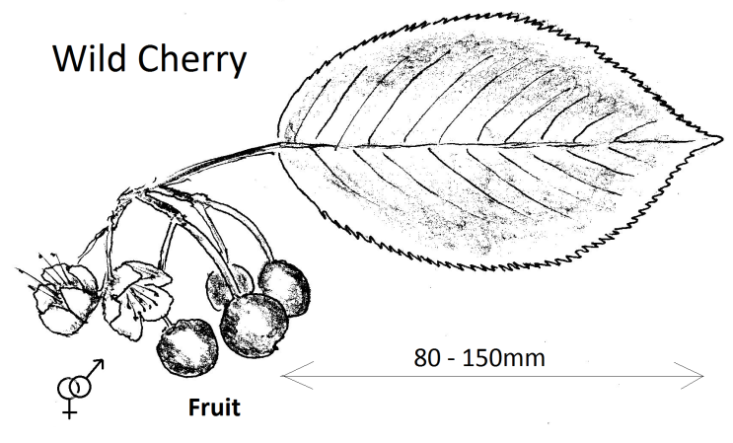
Wild Cherry
Flowers: April -May. 5 white petals, sometimes not fully open. Develops into dark red, or sometimes yellowish fruit with a single seed (stone) inside.
Bark is shiny, red-brown horizontal bands which can peel.
Native plant.
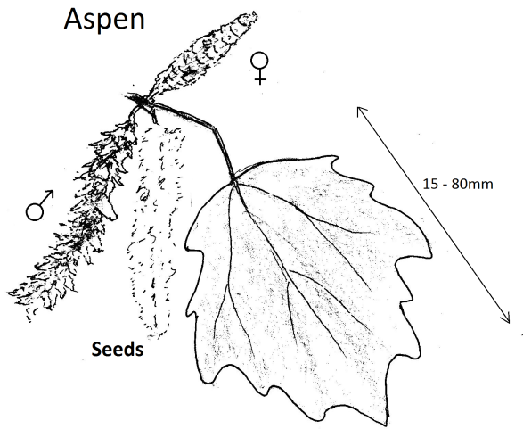

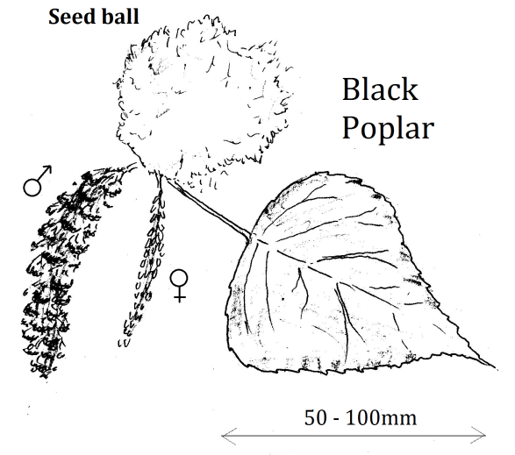

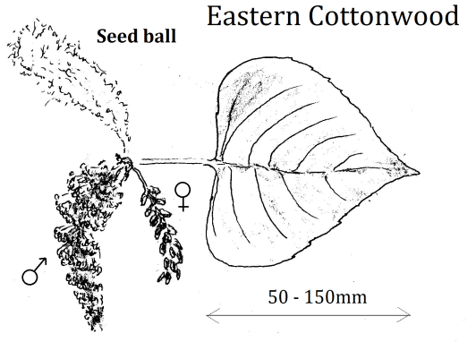

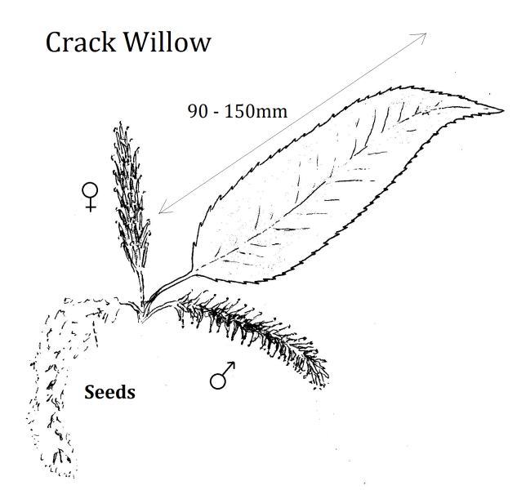

Aspen
A member or the poplar family it produces catkins in February and March. The male and female, red-purple, catkins are produced on separate trees.
The greyish bark is smooth but can be deeply fissured towards the base. There are roundish lenticles (holes) in the bark. The leaf stalks are flattened so that in breezes they flutter.
The small fruits release numerous tiny seeds with tufts of white hair.
Native plant.
Black Poplar
It produces catkins in March. The male and female, red-purple, catkins are produced on separate trees.
The trunk has many large burrs or bosses and the main branches spread widely and arch downwards.
It grows quickly and is very useful because of its whitish, easily worked timber. It has been extensively hybridized, particularly with the Eastern Cottonwood, so that identifying a native Black Poplar is difficult. There are thought to be fewer than 400 female Black Poplars left in the UK, could ours be one of them?
Eastern Cottonwood
Catkins are produced in March and April on separate trees. The bark is grey and fissured. Originally from the USA, it was introduced here to improve the quality of our native Black Poplar for the timber trade.
Males are preferred to female trees as the mass of white-hairy seeds produced in the autumn interfered with the wood to be worked. Males are propagated from cuttings.
Crack Willow.
Male, yellow catkins and female green catkins born on separate trees in April and May.
It can develop into a large, sprawling tree. Its branches give a characteristic “crack” when broken from the stem.

